EXP NO 3: CREATE A SIMPLE CLOUD SOFTWARE APPLICATION FOR PROPERTY BUYING & RENTAL PROCESS (IN CHENNAI CITY) USING ANY CLOUD SERVICE PROVIDER TO DEMONSTRATE SAAS.

AIM: To Create a simple cloud software application for Property Buying & Rental process (In Chennai city) using any Cloud Service Provider to demonstrate SaaS.

PROCEDURE:

Step1: go to zoho.com
Step 2: login to the zoho.com
Step 3: Create an application and open it.
Step 4: give a name as Property and Rentals to the application and add a form in the name Rental application.
Step 5: Add the required fields like name,date,phone number,email,from,to..etc.
Step 6:Click done and run the application.

OUTPUT:

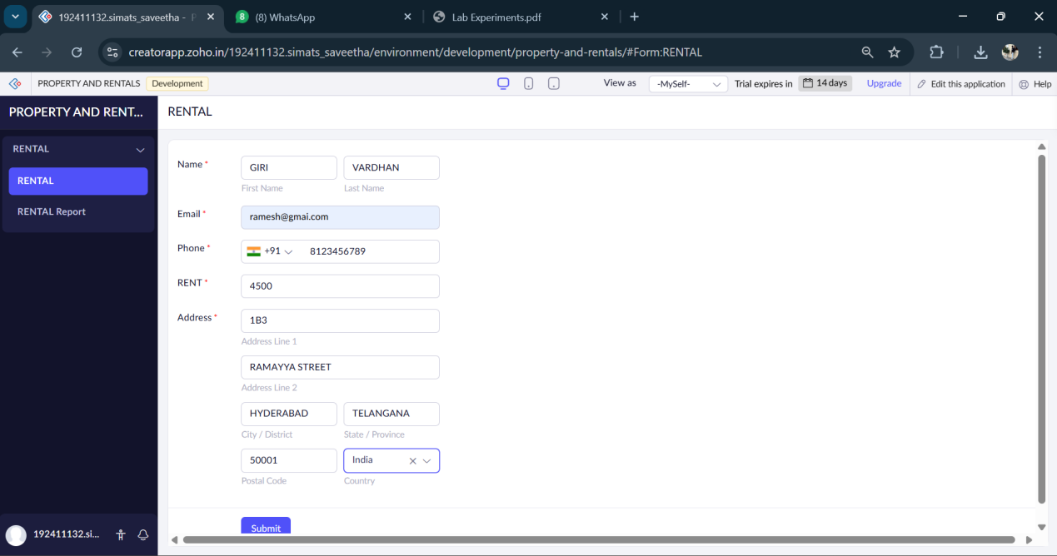

RESULT:

We have sucessfully created a simple cloud software application for property buying & rental process (in chennai city) using any cloud service provider to demonstrate saas.

